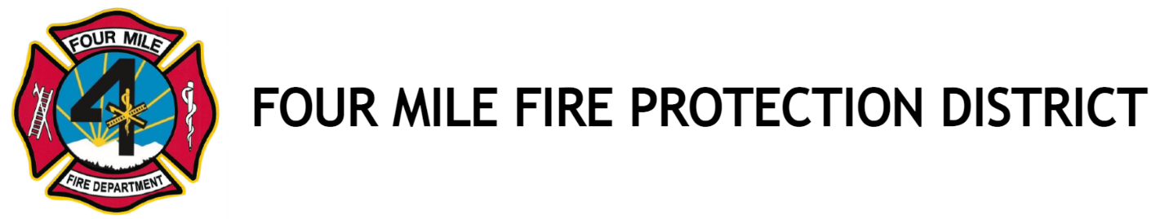

Regular Meeting of the Directors
March 18, 2026
NOTICE IS HEREBY GIVEN that a regular meeting of the Board of Directors of the Four Mile Fire Protection District will be held at 8437 Teller Country Road 11, Florissant, Colorado 80816 on Wednesday, March 18, 2026 at 7:00 pm.
Effective May 25, 2022, we will no longer entertain comments from the public during the board meetings. Public comments will be welcome near the end of the meeting just as your agenda indicates. Everyone will be given 3 minutes to speak. If we are unable to answer your question, it will be answered at the next board meeting.
AGENDA & MINUTES
- Call to Order: 7:00 pm. Date 3/18/26
A. Roll call for quorum: Quorum met

- Previous Minutes – February 18, 2026 - Motion to accept – Randy – 1st, Paul -2nd, Motion passed.

3. Treasure’s Report –Paul possible contingency fund. Motion to create $86,000 contingency fund. Randy – 1st, Bob – 2nd, Motion passed. Review monthly - goal $300,000.
A. Wendy – discussion of:
1. Funding workers compensation
2. Selecting a new auditor, reviewing options, settle at next meeting
3. Paying deployed employees then getting reimbursed
B. Motion to accept treasurer’s report - Randy – first, Bob – second

4. Old Business –
A. New truck, Four Mile Fire currently unable, new truck discussion tabled, motion to table – Randy – 1st, Paul – 2nd, Motion passed.
5. New Business –
A. New Truck Options, Talks pending with benefactor
B. Possible bank Change - motion to change from Bank of the San Juans to Park State Bank – Bob – 1st, Randy – 2nd, Passed.
C. Due to John Leblanc moving out of state, we are short board member.
- Gayle Vetter, nominated to replace – Randy 1st, Paul 2nd, passed. Gail to be sworn in at next meeting.
6. Brigade Chief report
- Event Calendar in the Courier
- Spaghetti Dinner - April 25, 2026
- Further Discussion of Garage Sale
7. Chief’s report
A. 27 Calls in the previous month
B. 0 controlled burns
C. $182, 000 pending reimbursement
D. 2 more EMTs pending
E. Will be managing 3 state burns approximately $12,000 income
F. Training in house paid $400, saved $7200
G. Crews currently in Nebraska, planning crew swap end of month
H. Pending grant $150,000 for fire mitigation
G. Planning to retrieve fire tender truck from mechanic, still not repaired!
8. Public Comments
A. Discussion of evacuation routes from housing developments
9. Motion to adjourn 8:15 pm, Randy – 1st, Paul – 2nd, Passed.

